Agrinode - Water Monitoring System for Paddy Field Project

Tien Cao-hoang

[Institutional Affiliation(s)]

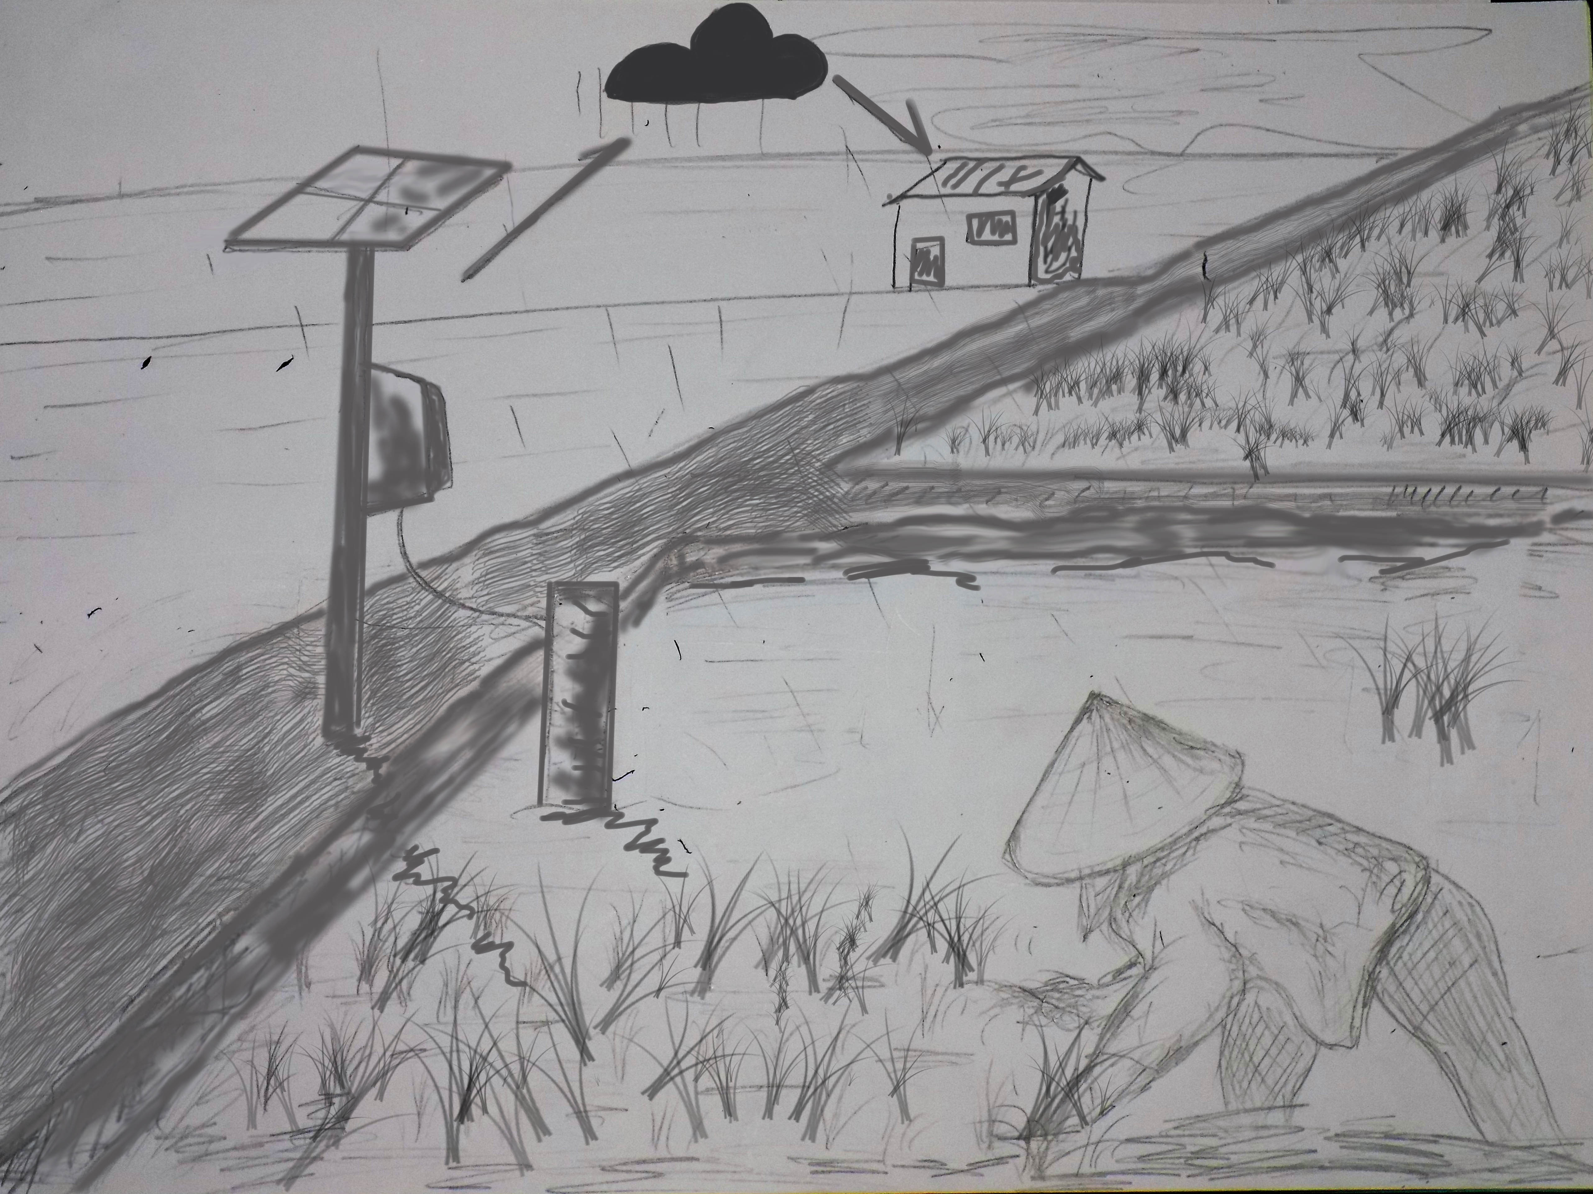

Author Note

This is a participant project for Open IoT Challenge 2.0

Abstract

Water level is one of the most important elements in paddy production. This project arms to develop an automatic water level monitoring system for paddy field. The system collects water level signal in real time by using Raspberry Pi 2. Then the data are sent to webserver where data are stored, managed, analyzed, and used to predict water status on the field in the next few days. Finally, the water information is sent to farmers via SMS or smart phone application. Therefore, the main key of project is to provide water status information to farmers.

Keywords: [Click here to add keywords.]

# I. System architect

# [Heading 1]

[The first two heading levels get their own paragraph, as shown here. Headings 3, 4, and 5 are run-in headings used at the beginning of the paragraph.]

## [Heading 2]1

[To add a table of contents (TOC), apply the appropriate heading style to just the heading text at the start of a paragraph and it will show up in your TOC. To do this, select the text for your heading. Then, on the Home tab, in the Styles gallery, click the style you need.]

[Heading 3]. [Include a period at the end of a run-in heading. Note that you can include consecutive paragraphs with their own headings, where appropriate.]

[Heading 4]. [When using headings, don’t skip levels. If you need a heading 3, 4, or 5 with no text following it before the next heading, just add a period at the end of the heading and then start a new paragraph for the subheading and its text.] (Last Name, Year)

[Heading 5]. [Like all sections of your paper, references start on their own page. The references page that follows is created using the Citations & Bibliography feature, available on the References tab. This feature includes a style option that formats your references for APA 6th Edition. You can also use this feature to add in-text citations that are linked to your source, such as those shown at the end of this paragraph and the preceding paragraph. To customize a citation, right-click it and then click Edit Citation.] (Last Name, Year)

References

Last Name, F. M. (Year). Article Title. *Journal Title*, Pages From - To.

Last Name, F. M. (Year). *Book Title.* City Name: Publisher Name.

Footnotes

1[Add footnotes, if any, on their own page following references. For APA formatting requirements, it’s easy to just type your own footnote references and notes. To format a footnote reference, select the number and then, on the Home tab, in the Styles gallery, click Footnote Reference. The body of a footnote, such as this example, uses the Normal text style. (Note: If you delete this sample footnote, don’t forget to delete its in-text reference as well. That’s at the end of the sample Heading 2 paragraph on the first page of body content in this template.)]

Tables

Table 1

[Table Title]

|  |  |  |  |  |
| --- | --- | --- | --- | --- |
| Column Head | Column Head | Column Head | Column Head | Column Head |
| Row Head | 123 | 123 | 123 | 123 |
| Row Head | 456 | 456 | 456 | 456 |
| Row Head | 789 | 789 | 789 | 789 |
| Row Head | 123 | 123 | 123 | 123 |
| Row Head | 456 | 456 | 456 | 456 |
| Row Head | 789 | 789 | 789 | 789 |

Note: [Place all tables for your paper in a tables section, following references (and, if applicable, footnotes). Start a new page for each table, include a table number and table title for each, as shown on this page. All explanatory text appears in a table note that follows the table, such as this one. Use the Table/Figure style, available on the Home tab, in the Styles gallery, to get the spacing between table and note. Tables in APA format can use single or 1.5 line spacing. Include a heading for every row and column, even if the content seems obvious. A default table style has been setup for this template that fits APA guidelines. To insert a table, on the Insert tab, click Table.]

Figures

Figure 1. [Include all figures in their own section, following references (and footnotes and tables, if applicable). Include a numbered caption for each figure. Use the Table/Figure style for easy spacing between figure and caption.]

For more information about all elements of APA formatting, please consult the APA Style Manual, 6th Edition.